Pronunciation

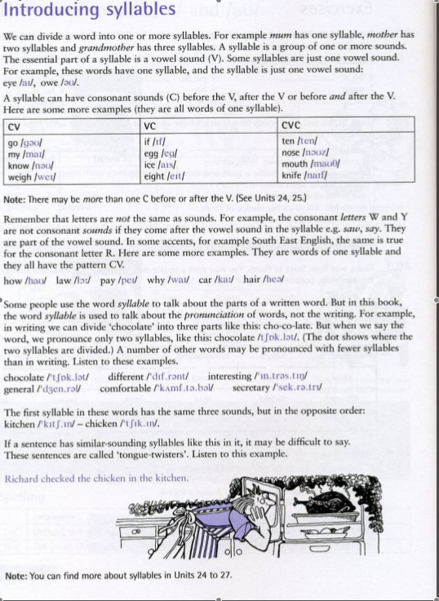

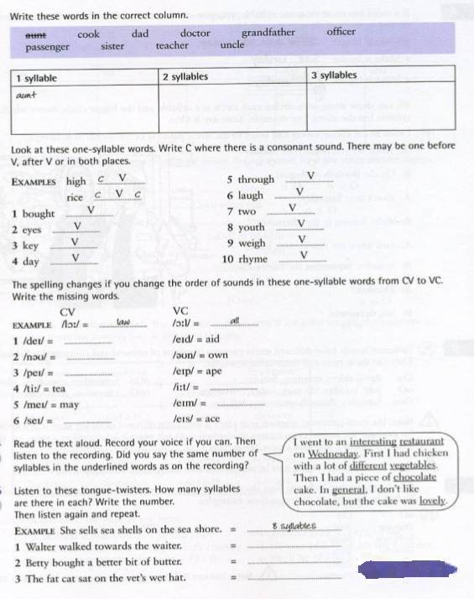

Review
Did you hear what happened ____________ Miss Smith.
No?
She was walking to her car last night and someone _____________ her.
No.
They _________________ her purse, which had her keys and everything in, so she couldn’t drive home. Got a taxi. Came back the next morning to find her car ___________ stolen.
No.
I’m serious. ___________ is that?

A: What's the matter Jihyeon?
B: nothing miss.
A: Well if you have something to say, we'd ____________________ it if you'd share it with us all.
further whispering
A: Alright, that's enough. What's going on? _____________ yourself, or you'll ________________ detention.
B: It's just that.....

Dialogue
Ok class, today we’re looking at Venn diagrams. Now does anybody know what a Venn diagram is?..No?
Well, Venn diagrams (or set diagrams) are illustrations used in mathematics to show all of the possible mathematical or logical relationships between sets (groups of things).
Err.. Sir?
Yes, Jimmy. What is it?
Could you run that by me again please sir.
Which part?
All of it.
It may be better if I show you an example. Hold on and I’ll show you.

Grammar
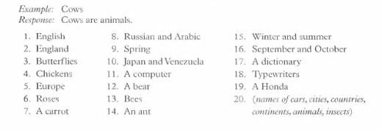

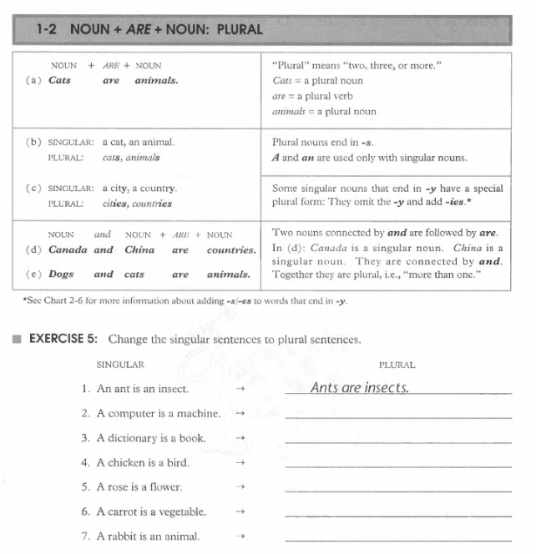

Did you hear what happened with Miss Smith.
No?
She was walking to her car last night and someone attacked her.
No.
They made off with her purse, which had her keys and everything in, so she couldn’t drive home. Got a taxi. Came back the next morning to find her car had been stolen.
No.
I’m serious. How bad is that?

A: What's the matter Jihyeon?
B: nothing miss.
A: Well if you have something to say, we'd appreciate it if you'd share it with us all.
further whispering
A: Alright, that's enough. What's going on? Explain yourself, or you'll be up on detention.
B: It's just that.....
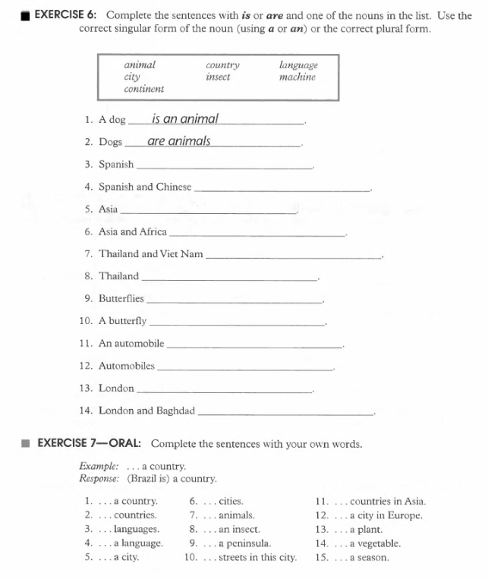

Keep a journal of this week.
Document all the TV shows you watch.

